QR Test Document

1. QR Codes:

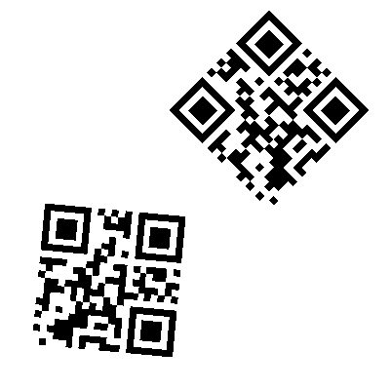

Response:

{

"Id":1,

"barData":[

{ "data":"Thalassiodracon",

"type":"QRCODE"},

{

"data":"Thalassiodracon",

"type":"QRCODE"}],

"image":"","

status_code":100

}

1. Live Images:  
   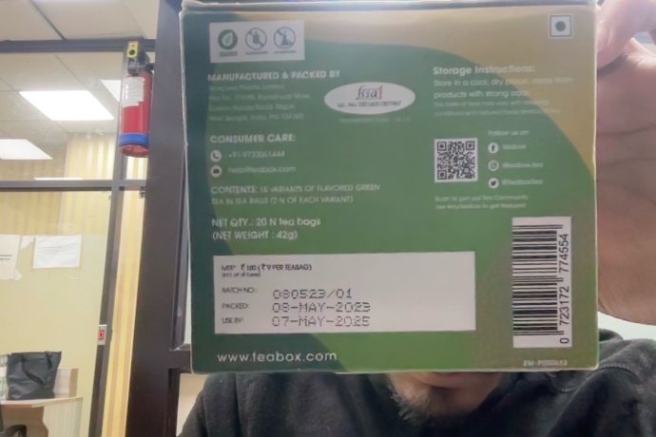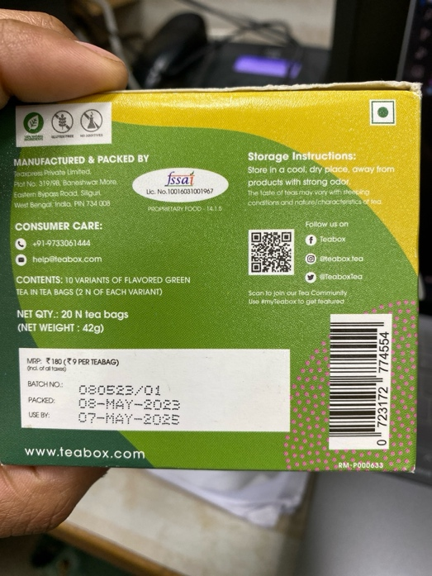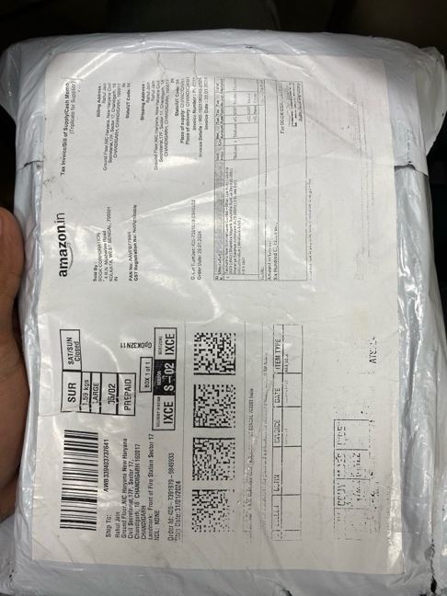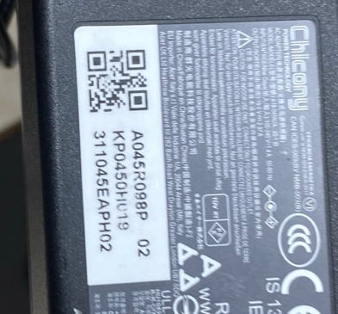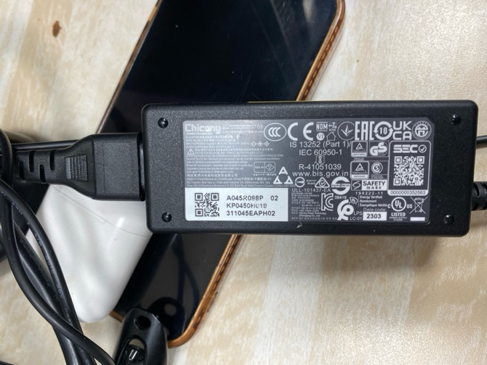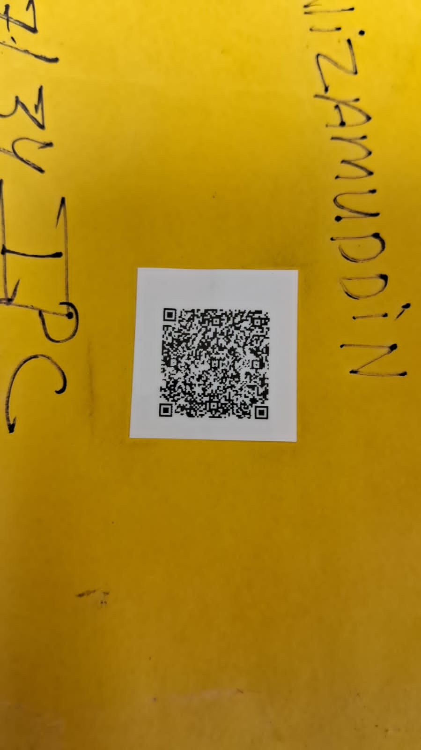  
     
     
   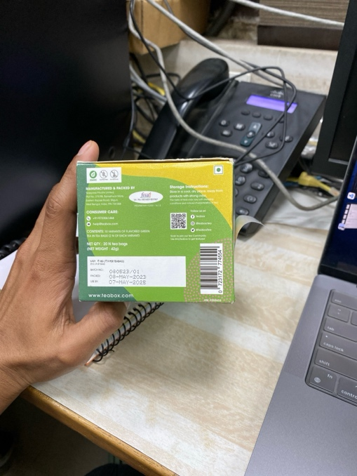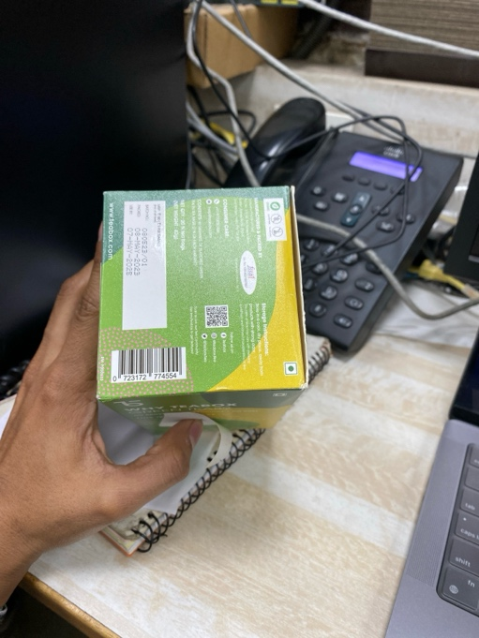  
     
     
   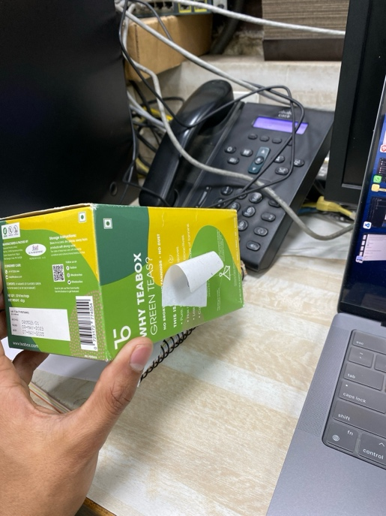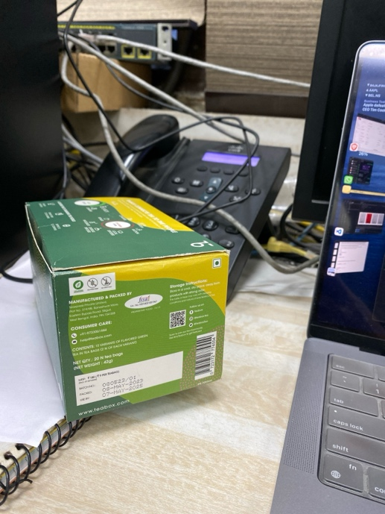

C

B

A

F

E

D

H

G

J

I

Limitations:

In Figure I and H QR data was not detected due to angle restrictions